STROMBOLI (1949)

*Stromboli* is a film by Italian director Roberto Rossellini, known for its tension between realism and fiction. Its modernism arises from the irreconcilability of these two modes and the film’s awareness of the impossibility of its project. Ingrid Bergman plays the part of Karin, an Eastern European refugee in Italy in 1948, who marries Antonio, a southern Italian soldier, in order to obtain a visa. After the marriage they journey to Stromboli, Antonio's native island, where their incompatibility ‒ both in temperament and physical appearance ‒ is reinforced through camerawork and an emphasis on the harsh landscape of the volcanic island. Antonio's possessive and abusive relationship with his wife is expressed through medium and close-up frames as well as tracking shots, which trap Karin and depict her tortured emotional state. Critics have commented on the editing as reflective of the controlling nature of Rossellini’s relationship with Bergman off-screen. Reviews have emphasized the representation of psychological aspects of Karin, who is isolated and rejected by the town. Since Bergman was banished from Hollywood after the film's release due to her scandalous affair with Rossellini during the filming, critical discourse has focused disproportionately on the off-screen affair. However, in recent years, the film has been recognized for it modern approach as an open-ended project, requiring viewers to explore divergent interpretations and construct their own meanings.

\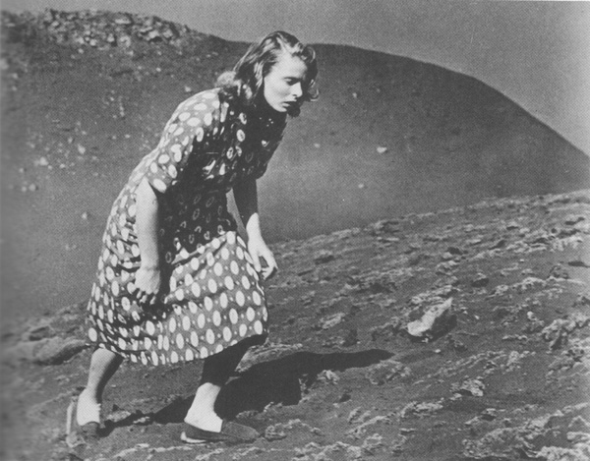

<http://www.afilmcanon.com/journal/2008/9/27/rossellini-stromboli-1950.html>

References and further reading:

Bingham, A. (2011) ‘Stromboli’ in Louis Bayman (ed.) *Directory of World Cinema: Italy,* Bristol: Intellect: 77-79.

Bondanella, P. (2001) *Italian Cinema from Neorealism to the Present – Third Edition,* New York: Continuum.

Gelly, O. (2012) *Stardom and the Aesthetics of Neorealism,* New York: Routledg.

Paratextual material:

Photos and Images

<http://www.filmtv.it/film/6912/stromboli-terra-di-dio/foto/1/>

Stromboli Final Scene

<https://www.youtube.com/watch?v=8u3NWCvBFaE>

Maria Alexandra Catrickes  
Yale University